Lesson 10 Silicon valley

integrated ['ɪntɪgreɪtɪd] adj. 各部分完美组合在一起的，综合的

integrated adj. with various parts fitting well together an integrated public transport system

integrated circuit

integrate A with B

integrate theory with practice

One of the attractive features of the course was the way the practical work had been with the theoretical aspects of the subject.

(A) integrated (B) embedded

(C) embraced (D) synthesized

penalize ['pi:nəlaɪz] v. 处罚，惩罚

penalize v. to officially punish someone, usually implies a monetary penalty or the forfeiture of a privilege for breaking a rule or law

People who drive when they are drunk should be heavily penalized. penalize sb. for sth.

A referee may penalize players for wasting time.

penalty death penalty

capital punishment

fine fine sb. (money) for sth. He was fined $300 for reckless driving.

sentence be sentenced to … He was sentenced to

10 years in prison. life imprisonment. death.

discipline

discipline sb. for sth.

The worker was disciplined for insubordination.

customize ['kʌstəmaɪz]

v. 为用户定做，使个人化

a customized car

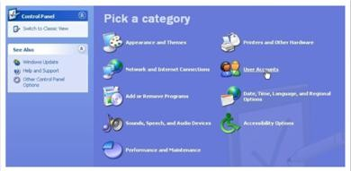You can use the control panel to customize Windows.

civilize

generalize localize pulverize

spawn [spɔ:n]

v.（鱼或青蛙）产卵；引起，引发

spawn v. to make a series of things happen or start to exist New technology has spawned new business opportunities. breed

Unemployment breeds social unrest.

give birth to …

Marx’s ideas gave birth to communism. propagate

Such lies are propagated in the media.

thrive [θ raɪv]

v. 植物茁壮成长；兴旺，繁荣This type of plant thrives in tropics. thrive = prosper

a thriving / prosperous industry

A business cannot thrive / prosper without investment.

anarchy ['ænəki]

n. 无政府状态；混乱

In the absence of their teacher, the class was in a state of anarchy. arch(y) = rule

monarch monarchy

Britain is a monarchy.

patriarchy matriarchy

oriental [7ɔ:ri'entl]

adj. 东方的；n. 东方人

the Orient occidental the Occident

Negro / Black

African-American/Afro-American

Eskimo Inuit

Oriental Asian

Chinese Korean Japanese

Asian-American

Chinese-American Korean-American Japanese-American

constitute ['kɒnstɪtju:t]

v. 组成，形成，构成

Twelve months constitute a year.

The rise in crime constitutes / poses a threat / menace to society. constitution constitutional

constitutional monarchy

drove [drəʊv]

n. 一群牲畜；移动的人群a drove of horses / cattle … in droves

Tourists come in droves to see the Imperial Palace.

innovator ['ɪnəveɪtə(r)]

n. 革新者，创新者

innovate innovate in techniques innovation

“nov” = new

novel a novel idea

novelty

The car was a novelty in 1900.

novice

renovate renovation

The Imperial Palace is under renovation.

forge [fɔ:dʒ]

v. 打铁，锻造； 建立联系；伪造forge a sword

a relationship

forge an alliance with …

a link

The United Sates forged an alliance with France in 1776.

a forged passport forgery

The painting is a forgery.

California n. a state in the western United states, bordering the Pacific Ocean, the third largest state in the country

Silicon Valley

a region of western California, south of San Francisco

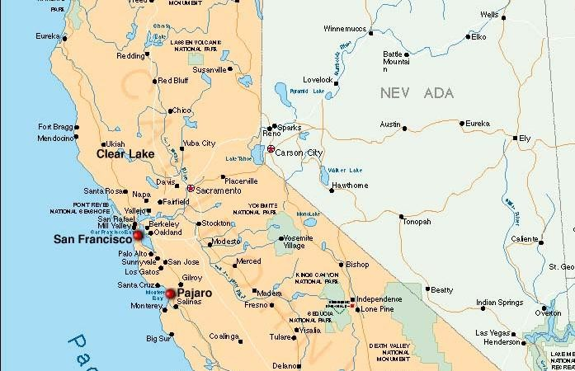

It is a center of the computer industry. Many important inventions were made in this area, and many companies producing computer software and hardware are based there.



It is called Silicon Valley because the computer industry is based on the silicon chip.

trend n. a general tendency in the way a situation is changing or developing 趋势；潮流

Carver Mead, *a pioneer in integrated circuits and a professor of*

*computer science at the California Institute of Technology*, notes there are now work-stations *that enable engineers to design, test and produce chips right on their desks, much the way an editor creates a newsletter on a*

*Macintosh*.

California Institute of Technology (CIT)



Harvard University



Massachusetts Institute of Technology (MIT)



Stanford University



California Institute of Technology (CIT)



University of California at Berkeley(UC Berkeley)



Stanford University

University of California at Berkeley California Institute of Technology

note v. 1. notice or pay attention to sth. Note how she is holding her racket.

note v. 2. mention sth. because it is important or interesting

He observed that it would probably rain.

There is, I think, much truth in Patricia Nelson Limerick ’ s observation that “lecturing is an unnatural act, an act for which God did not design human.”

With the start of BBC World Service Television, millions of viewers in Asia and America can now watch the Corporation’s news coverage, as well as listen to it.

Social science disciplines include geography, economics, political science, psychology, and sociology.

“The test of any democratic society,” he wrote in a *Wall Street Journal* column, “lies not in how well it can control expression but in whether it gives freedom of thought and expression the widest possible latitude, however disputable or irritating the results may sometimes be.

workstation n. a desk for one person to work at, usually with a computer or computer terminal

enable sb. to do

allow / permit sb. to do make it possible for sb. to do

… allow / permit engineers to design, test and produce chips …

… make it possible for engineers to design, test and produce chips …

newsletter n. a printed report sent regularly to a particular group of people

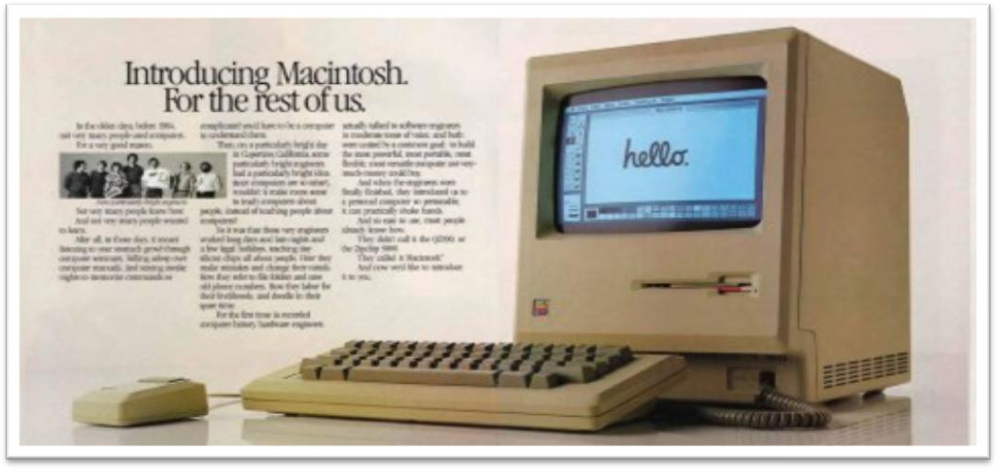Macintosh n. (Mac) personal computer, developed by Apple Computer Corporation in 1984.

It pioneered the use of a graphical interface.

The steak is cooked the way I like it.

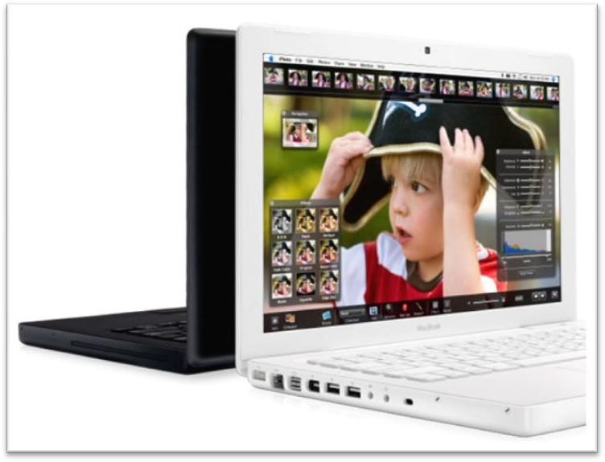

= The steak is cooked in the way I like it.

= The steak is cooked as I like it.

much adv. nearly; about; approximately The patient's situation is much the same.

造句：因特网技术可以使你能够在家中购物，这与你在普通商店买东西差不多。

Internet technology enables you to make purchases at home, much the way you do in regular shops.

As the time and cost of making a chip drop to a few days and a few hundred dollars, engineers may soon be free to let their imaginations soar without being penalized by expensive failures.

drop / fall / decrease *(to …)*

plummet / plunge / nosedive / take a nosedive *(to …)*

Since January, sales of cars have plummeted / plunged / nosedived / taken a nosedive.

rise / go up / increase / climb / escalate *(to …)* House prices have escalated *to* a worrying level. soar / rocket *(to …)*

Gold prices soared / rocketed *to* their highest level since 1983. metaphor 暗喻(喻体全隐式)

His hunger gnawed at him.

Some books are to be tasted, others to be swallowed and some few to be chewed and digested.

— Sir Francis Bacon

Mead predicts that inventors will be able to perfect powerful customized chips over a weekend at the office—*spawning a new*

*generation of garage start-ups and giving the U.S. a jump on its foreign rivals in getting new products to market fast*.

predict foretell

Timely snow foretells a bumper harvest. perfect bring … to perfection

The violinist spent years perfecting his technique. The violinist spent years bringing his technique to perfection.

start-up n. a new small company, esp. one whose work involves computers or the Internet

an Internet start-up

get a jump on sb.

gain an advantage over sb. give sb. a jump on sb.

We’ve got more promising garage start-ups.

thrive on sth.

He thrives on criticism.

I wouldn’t want much pressure, but she seems to thrive on it. We also thrive on Asians.

constitute / make up / compose / comprise

One hundred members constitute / make up / compose / comprise

the committee.

comprise / be made up of / be composed of / consist of

The committee comprises / is made up of / is composed of / consists

of 100 members.

majority minority

… constitute a high / large proportion / percentage of the engineering staffs …

biological engineering software engineering

the Democratic People’s Republic of Korea (DPRK) the Philippines

draw on sth. to use sth. for a particular purpose

It was a challenge, but luckily we had the experience to draw on.

use / make use of

wield

be able to wield both the pen and the sword exploit

exploit natural resources

Pacific Rim markets Pacific Rim weather Ph.D. (PhD):

doctor of philosophy

a lock on sth.

= complete control of sth.

… to challenge Japan’s near monopoly of the memory-chip market.

AT&T

American Telephone and Telegraph the largest telecommunications company in the United States, based in New York City.

financing funding

finance back fund subsidize

a charity financed / funded / backed by private donations a government-subsidized health service

sponsor



Before it no longer takes the lead in computer industry, …

You’ll learn a lot from Silicon Valley if you want to build a global business.